Slide 6

Engineering Standards
Standard | What It Is | How It Will Be Applied
IPC-2221 | PCB Design Standard | Used to guide the design, layout, and fabrication of custom PCBs for remote modules,  ensuring reliability, manufacturability, and electrical integrity.
IEEE 802.3 | Ethernet Standard for Wired LAN Communication | Applied to any wired network interfaces or connections between the gateway and web  interface for stable data transfer.
IEEE 802.11 | Wi-Fi Standard Operating in the 2.4 GHz ISM Band | Implemented for Wi-Fi connectivity in the gateway or modules to enable bi-directional  communication with the web interface.
IEEE 802.15.1 | Bluetooth/BLE Standard for short-range wireless communication | Utilized in remote modules for low-energy, short-range transmission and receiving,  supporting at least one of the required IoT protocols.
IEEE 802.15.4 | Zigbee and Thread Protocol foundation for low-power mesh networking | Applied to enable mesh topology in remote devices, supporting Zigbee or Matter over  Thread for multi-device control and bi-directional communication.
Matter Protocol Specification | Application layer standard for secure, interoperable smart devices | Integrated as an application layer on top of Thread or Zigbee to ensure secure,  interoperable control of remote devices via the web interface.
FCC Title 47 CFR Part 2 | Covers frequency allocation and equipment authorization | Ensured for all transmitting devices to comply with frequency allocation requirements in  the 2.4-2.5 GHz ISM band.
FCC Title 47 CFR Part 15 | Regulations for unlicensed RF devices (e.g., Wi-Fi, Bluetooth, Zigbee) | Applied to verify that remote modules and the overall system operate within unlicensed  limits without causing interference.
FCC Title 47 CFR Part 18 | Regulations for ISM equipment | Used to ensure compliance for industrial, scientific, and medical equipment operating  in the ISM band.

Slide 22

Subsystems | mAh | mA
Coin Cell Batteries  (CR2032 3V) | 220 mAh | N/A
Movement Detection | 265.44 mAh | 7.1 mA
Lighting | 26 minutes of  run time/battery | 100 mA
Speaker/Microphone | 105.9072 mAh | 16.94 mA
Doorbell | 47.32 mAh | 5.1 mA

Slide 24

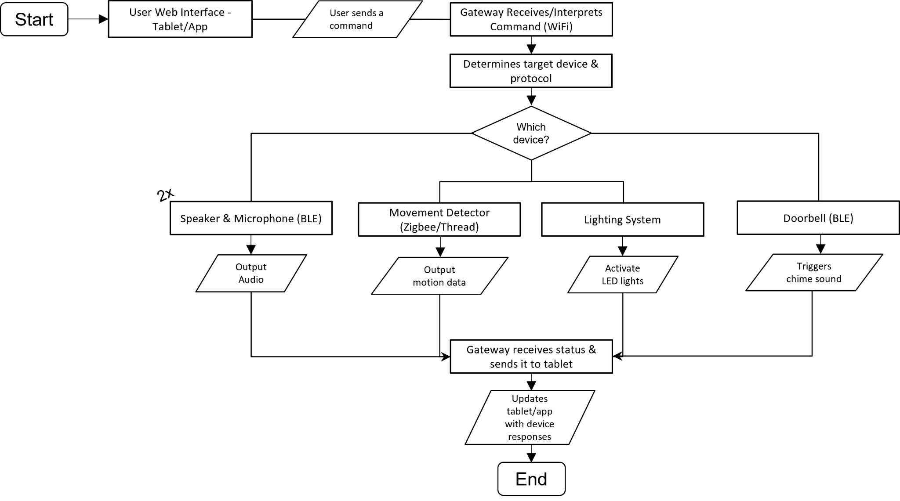

Slide 31
Parts List
Part | Description | Quantity | Supplier | Unit Cost | Total Cost | Lead Time | Notes | Link
EW840E5N | Open Source BLE 5.2/Thread/Zigbee to Ethernet, WiFi gateway | 1 | Fanstel | $95.52 | $107.52 | 1 week | Size: Individual | Fanstel
LR431U-7.2X7IR3 | 5V LED Light Strip with USB A connection | 3 | The Home Depot | $6.48 | $19.44 | 1 week | Due to the 5V voltage requirment, and data/Power connection the LED ligtht strip can only be found from a non approved vendor. | Home Depot
AU-Y1005 | USB-A 4 position female connector | 10 | Digikey | $0.63 | $6.30 | 21 weeks | High in stock | Digikey
MB1000-000 | Ultrasonic Sensor | 10 | Digikey | $19.95 | $199.50 | 2 weeks | Low in stock | Digikey
1775485-1 | 2032 coin cell battery holder | 20 | Digikey | $1.25 | $25.00 | 5 weeks | In stock | Digikey
SPG08P4HM4H-1 | 30 Hz ~ 10 kHz Digital, PDM Microphone MEMS | 10 | Digikey | $1.83 | $18.30 | 14 weeks | In stock | Digikey
3571 | J-Link debugger | 2 | Adafruit | $59.95 | $119.90 | 5 weeks | Low in stock | Adafruit
1675 | 10-pin 2x5 Socket-Socket 1.27mm IDC (SWD) Cable - 150mm long | 1 | Adafruit | $2.95 | $2.95 | 1 Week | In stock | Adafruit
GRPB052VWQS-RC | Connector Header Surface Mount 10 position 0.050" (1.27mm) | 10 | Digikey | $0.75 | $7.50 | 20 weeks | High in stock | Digikey
CSS-66668N | SPEAKER 8OHM 3W | 7 | Digikey | $4.18 | $29.26 | 15 weeks | Low in stock | Digikey
2177971022 | 2 Position Cable Assembly Rectangular Socket to Individual Wire Leads 0.984' | 20 | Digikey | $1.56 | $31.20 | 21 weeks | In stock | Digikey
22032021 | Connector Header Through Hole 2 position 0.100" (2.54mm) | 20 | Digikey | $0.22 | $4.40 | 15 weeks | High in Stock | Digikey
CL10A106KP8NNNC | 10 µF ±10% 10V Ceramic Capacitor X5R 0603 (1608 Metric) | 20 | Digikey | $0.02 | $0.44 | 31 weeks | High in stock | Digikey
CL10B104JB8NNNC | 0.1 µF ±5% 50V Ceramic Capacitor X7R 0603 (1608 Metric) | 90 | Digikey | $0.01 | $0.54 | 31 weeks | High in stock | Digikey
CMS11(TE12L,Q,M) | Diode 40 V 2A Surface Mount M-FLAT (2.4x3.8) | 20 | Digikey | $0.24 | $4.76 | 16 weeks | High in stock | Digikey
RC0603JR-070RL | 0 Ohms Jumper Chip Resistor 0603 (1608 Metric) | 40 | Digikey | $0.01 | $0.40 | 18 weeks | High in stock | Digikey
22032041 | Connector Header Through Hole 4 position 0.100" (2.54mm) | 20 | Digikey | $0.29 | $5.80 | 15 weeks | High in stock | Digikey
2177971042 | 4 Position Cable Assembly Rectangular Socket to Individual Wire Leads 0.984' (300.00mm, 11.81") | 20 | Digikey | $2.66 | $53.12 | 21 weeks | In stock | Digikey
DAC6551AQDGKRQ1 | 12 Bit Digital to Analog Converter 1 8-VSSOP | 10 | Digikey | $3.36 | $33.64 | N/A | High in stock | Digikey
TPA2034D1YZFT | Audio Amplifiers 2.75W Mon Fully Diff Class-D Aud Amp A 595-TPA2034D1YZFR | 10 | Mouser | $1.24 | $12.40 | 6 weeks | Low in stock | Digikey
8Q-32.000MEEV-T | 32 MHz ±10ppm Crystal 8pF 80 Ohms 4-SMD, No Lead | 10 | Digikey | $0.77 | $7.73 | 17 weeks | High in stock | Digikey
CR2032 | Coin, 20.0mm Lithium Manganese Dioxide 3 V Battery Non-Rechargeable (Primary) | 50 | Digikey | $0.24 | $12.05 | 18 weeks | High in stock | Digikey
OS102011MS2QN1 | Slide Switch SPDT Through Hole | 10 | Digikey | $0.61 | $6.08 | 12 weeks | High in stock | Digikey
LQM18PN3R3MFRL | 3.3 µH Shielded Multilayer Inductor 700 mA 438mOhm Max 0603 (1608 Metric) | 10 | Digikey | $0.14 | $1.36 | 10 weeks | High in stock | Digikey
CL10B105KP8NNNC | 1 µF ±10% 10V Ceramic Capacitor X7R 0603 (1608 Metric) | 80 | Digikey | $0.01 | $0.40 | 31 weeks | High in stock | Digikey
CL10A475KP8NNNC | 4.7 µF ±10% 10V Ceramic Capacitor X5R 0603 (1608 Metric) | 20 | Digikey | $0.01 | $0.12 | 31 weeks | High in stock | Digikey
CRCW08051R00FKEAHP | 1 Ohms ±1% 0.5W, 1/2W Chip Resistor 0805 (2012 Metric) Automotive AEC-Q200, Pulse Withstanding Thick Film | 10 | Digikey | $0.13 | $1.26 | 14 weeks | High in stock | Digikey
LDO40LPU33RY | Linear Voltage Regulator IC Positive Fixed 1 Output 400mA 6-DFN (3x3) | 10 | Digikey | $1.26 | $12.56 | 24 weeks | In stock | Digikey
RC0603FR-0710KL | 10 kOhms ±1% 0.1W, 1/10W Chip Resistor 0603 (1608 Metric) Moisture Resistant Thick Film | 40 | Digikey | $0.01 | $0.24 | 18 weeks | High in stock | Digikey
QPG6200LTR13 | Qorvo SOC 10DBM 4X4QFN32 | 10 | Mouser | $4.68 | $46.80 | 22 weeks | In stock | Mouser
 | JCL PCB 6 layer estimate | 5 | JLC PCB | N/A | $133.86 | N/A | N/A | JLC PCB
LDO40LPU50RY | Linear Voltage Regulator IC Positive Fixed 1 Output 400mA 6-DFN (3x3) | 10 | Digikey | $1.26 | $12.56 | 24 weeks | In stock | Digikey
OPA1612AIDRGT | Audio Amplifier 2 Circuit Rail-to-Rail 8-SON (3x3) | 10 | Digikey | $6.57 | $65.73 | 12 weeks | Low in stock | Digikey
600S2R2AT250XT4K | 2.2 pF ±0.05pF 250V Ceramic Capacitor C0G, NP0 0603 (1608 Metric) | 20 | Digikey | $1.11 | $22.20 | 12 weeks | In stock | Digikey
600S1R5BT250XT4K | 1.5 pF ±0.1pF 250V Ceramic Capacitor C0G, NP0 0603 (1608 Metric) | 20 | Digikey | $0.72 | $14.30 | 12 weeks | High in stock | Digikey
600S1R8BT250XT4K | 1.8 pF ±0.1pF 250V Ceramic Capacitor C0G, NP0 0603 (1608 Metric) | 20 | Digikey | $0.91 | $18.14 | 12 weeks | High in stock | Digikey
600S180FT250XT4K | 18 pF ±1% 250V Ceramic Capacitor C0G, NP0 0603 (1608 Metric) | 40 | Digikey | $1.55 | $61.92 | 12 weeks | In stock | Digikey
MHQ0402PSA2N9ST000 | 2.9 nH Shielded Multilayer Inductor 250 mA 600mOhm Max 01005 (0402 Metric) | 20 | Digikey | $0.03 | $0.60 | 12 weeks | High in stock | Digikey
B0C8HWQYXF | Elegoo 1 kg 3d printer filament (marble) | 3 | Amazon | 21.99 | 65.97 | 1 week | In stock | Amazon
B0D3X5CT2J | M3 Bolt Set | 1 | Amazon | 7.99 | 7.99 | 1 week | In stock | Amazon
B079KTVRC9 | Apache 3800 carrying case | 1 | Amazon | 49 | 49 | 1 week | In stock | Amazon
B0CQMPSWMJ | Lenovo Tab M11 | 1 | Amazon | $153.52 | $153.52 | 1 week | In stock | Amazon
RP3502ARED | Pushbutton Switch SPST-NO Standard Panel Mount, Front | 10 | Digikey | $1.98 | $19.80 | 17 weeks | In stock | Digikey
 |  |  |  | Total Cost | 1396.56

Slide 32
